Version 3.0

December 10, 2015

Will Rodriguez

Sergio saucedo



Player user guide

User Roles

Table of Contents

1. Introduction 2

2. Getting Started 3

Creating a new profile 3

Profile Page 4

Playing Assigned Routines 7

Simulator 8

3. Manage Account Information 9

## Introduction

While many areas have integrated technological advances quite easily and intuitively. Other areas have lacked the ability to incorporate technology to improve contemporary practices. Soccer is an area that has been unable to embrace technological advancements with the traditional game.

Soccer is a team focused sport. In which there is one coach whom directs how practices go, what type of training they will focus on, and what areas they should improve on. A problem arises when players want to improve on certain areas they feel they need improvement, and the coaches plans are to tackle on different skills. SkillCourt plans to solve this conflict of interest problems, by allowing a coach to create routines tailored to different players and allow the players to play them in their own time or during practice.

In SkillCourt, the coach will be able to create Custom as well as Default routines. Then the coach will assign these routines to different players.

The purpose of this document is to explain how the different users in SkillCourt can interact with the new system.

## Getting Started

We will start by first accessing the SkillCourt website.

Type in the following URL in your favorite web browser. (We recommend Google Chrome)

<http://www.skillcourt.com>

### Creating a new profile

We will now create a new profile.

1. Click on the Click here to Register link.

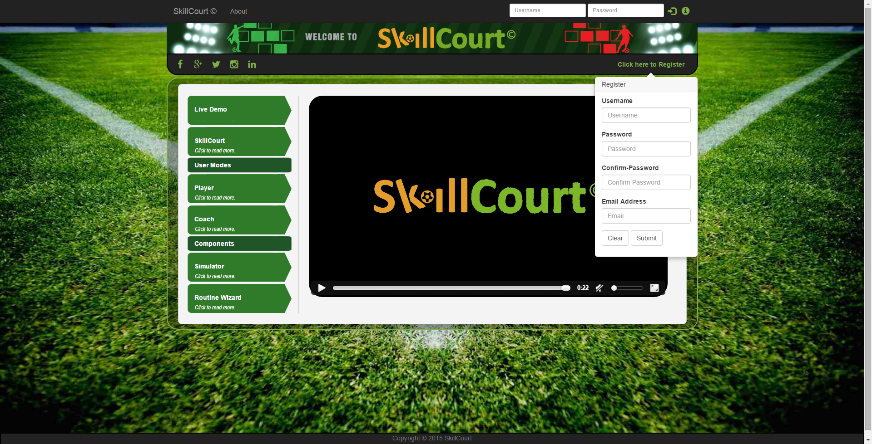

1. Now lets go ahead and enter all of your information. It is to note, that you cannot use an email address or username that has been used in the past.
2. Click Submit
3. Now you will receive an email address to the email address you just entered. Confirm the email address and go back to the SkillCourt site.

### Profile Page

Here you will be able to see your Personal Information, Athletic Profile, and Various Info.

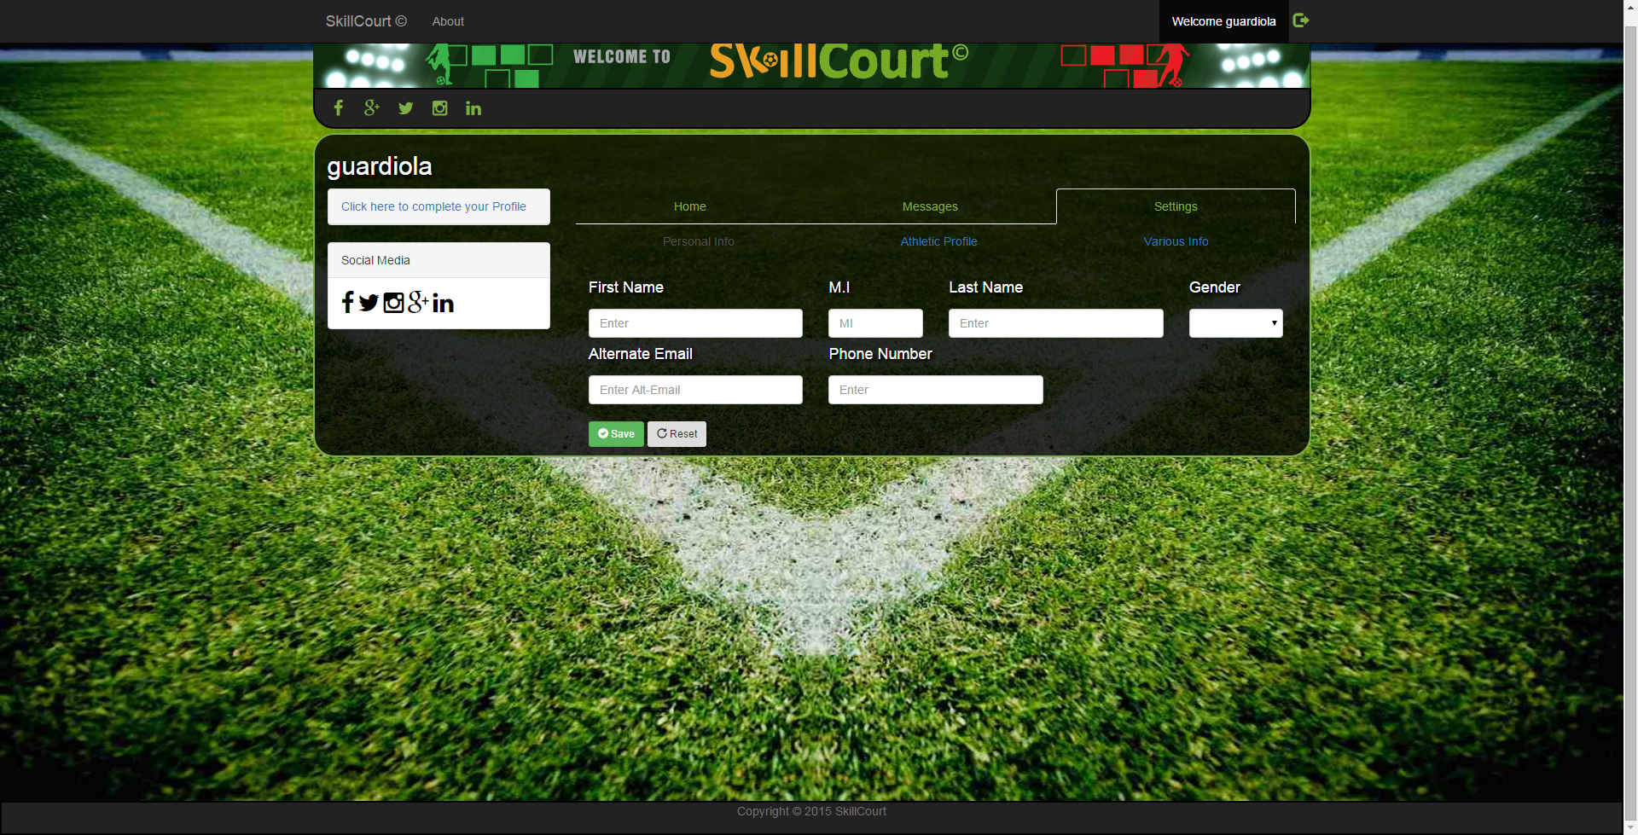

Before we continue, lets complete our profile by clicking on the Settings tab.

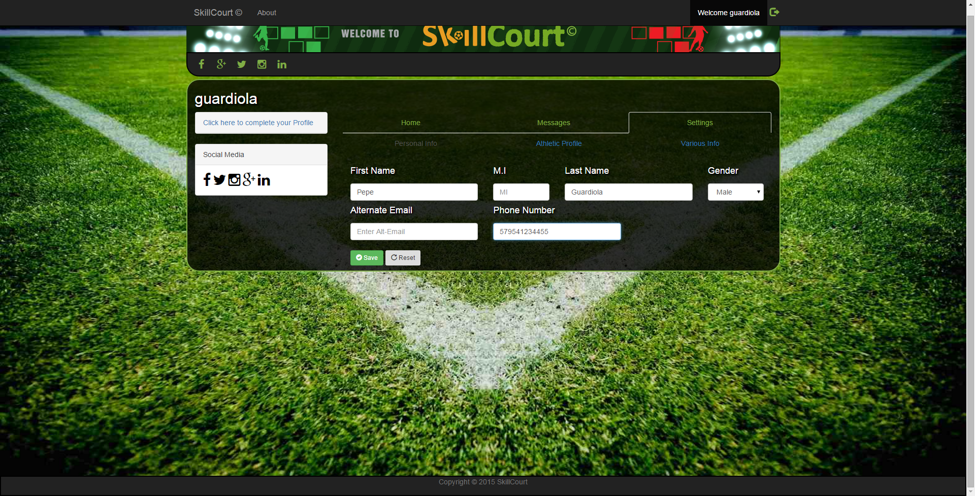

Enter your First Name, Last name, Gender, and Phone number. These are the only required fields.

**Once saved. We can see the Personal Information box show up on your profile pane.**

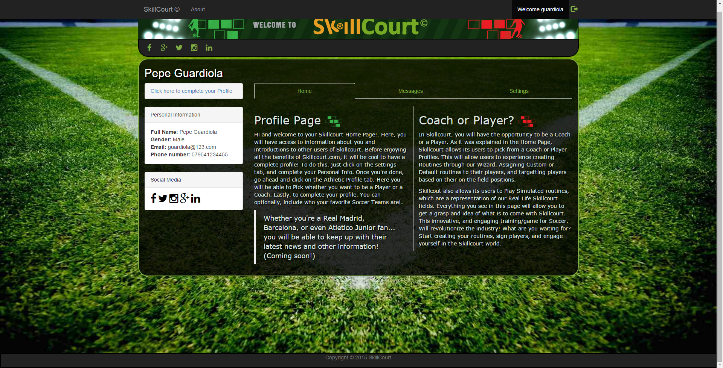

Let’s continue by choosing what type of User we will be using.

1. Click on the settings tab
2. Click on the Athletic Profile tab
3. And complete your information as a Player.

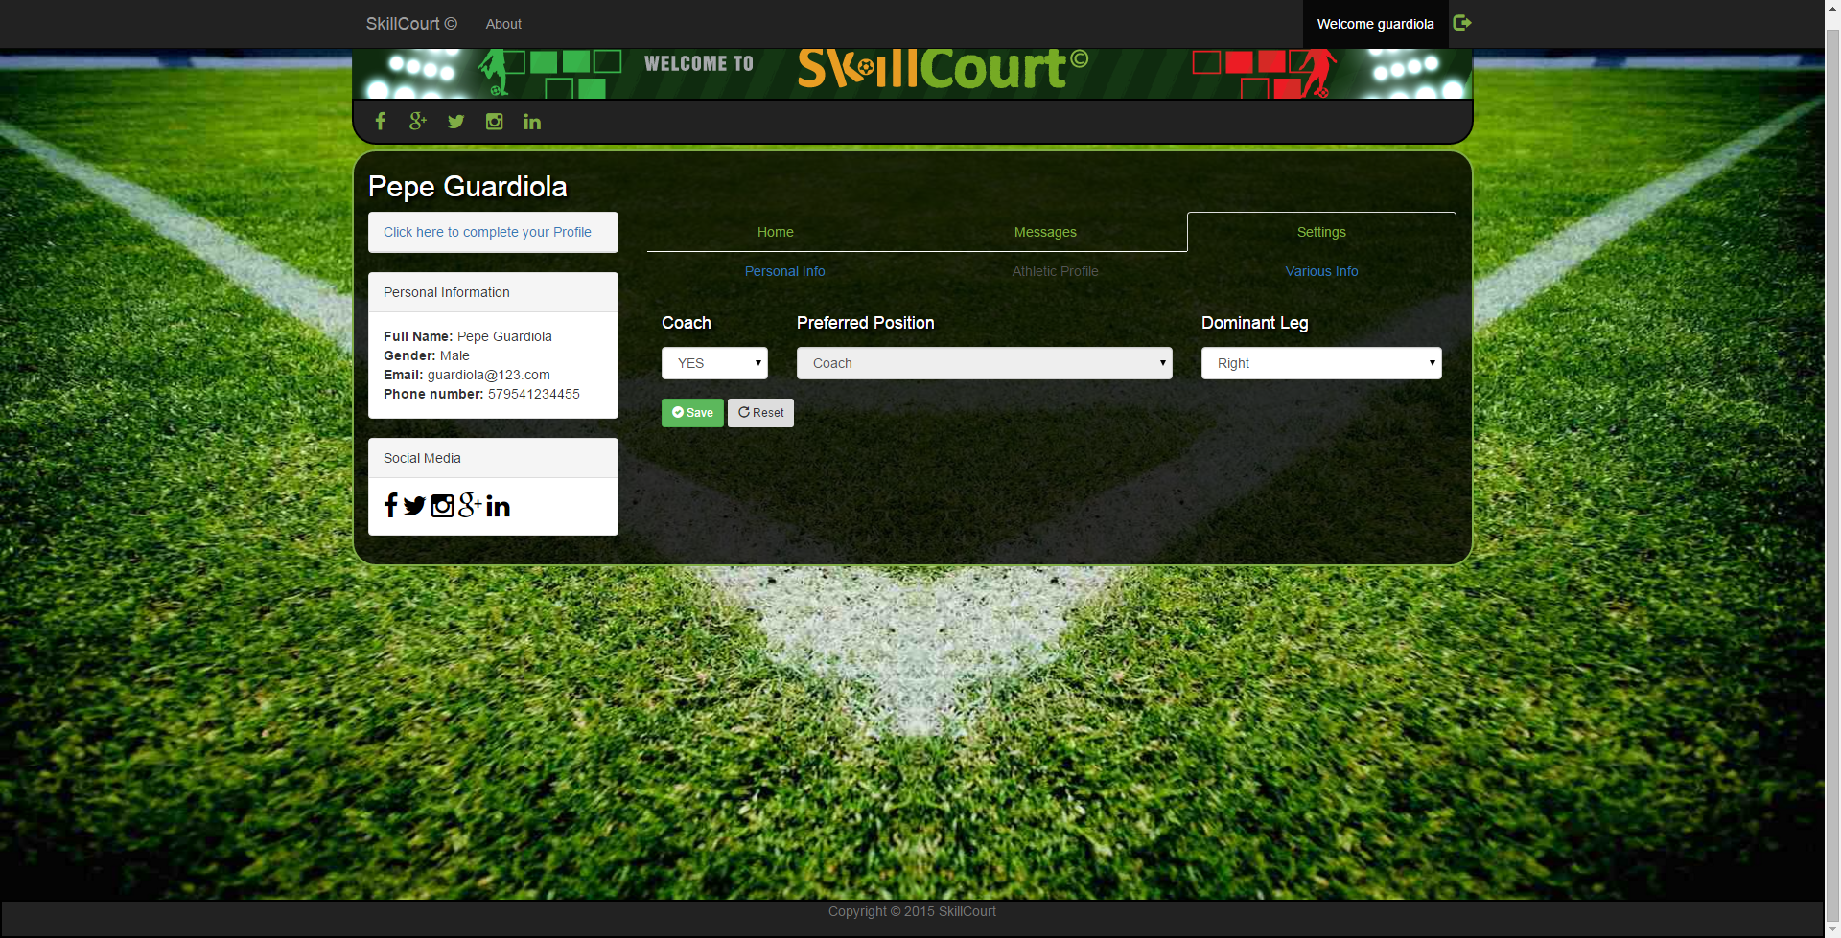

1. Once completed. Click on the save button, and 3 new links will show up on the top navbar.

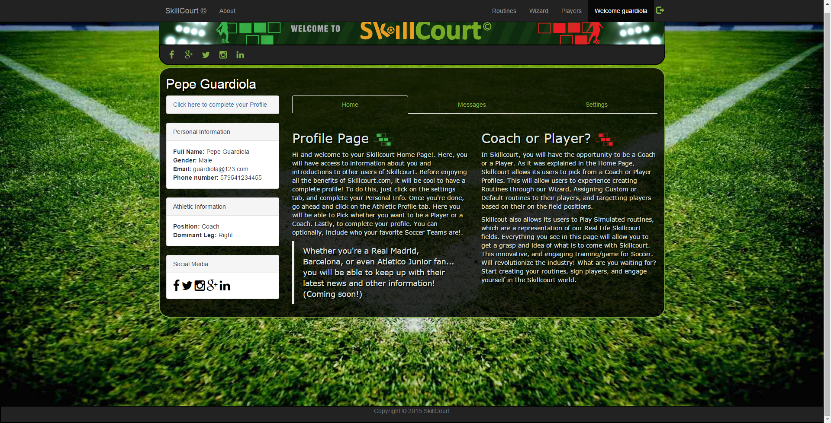

### CHOOSE aSSIGNED Routine

In the Routines page, a player is able to choose from assigned custom or default routines.

1. Click on the Routines link
2. Now the columns will populate as routines are assigned to the player by a Coach.
3. We have one default routine assigned
4. We can select it and click on play to simulate it.

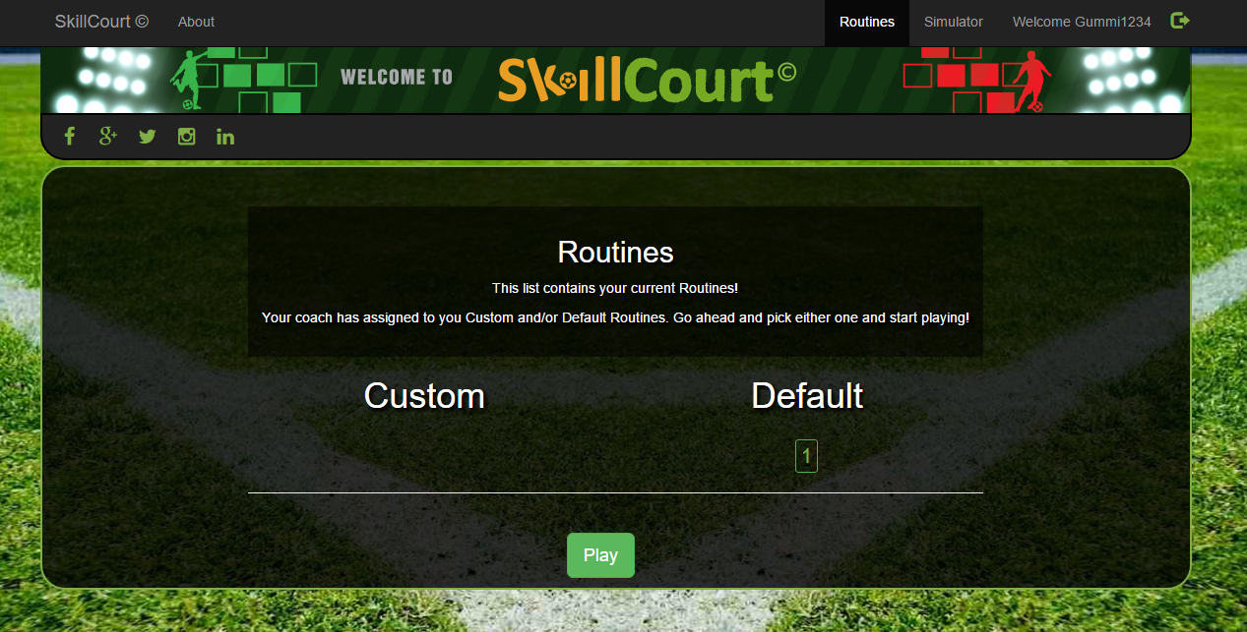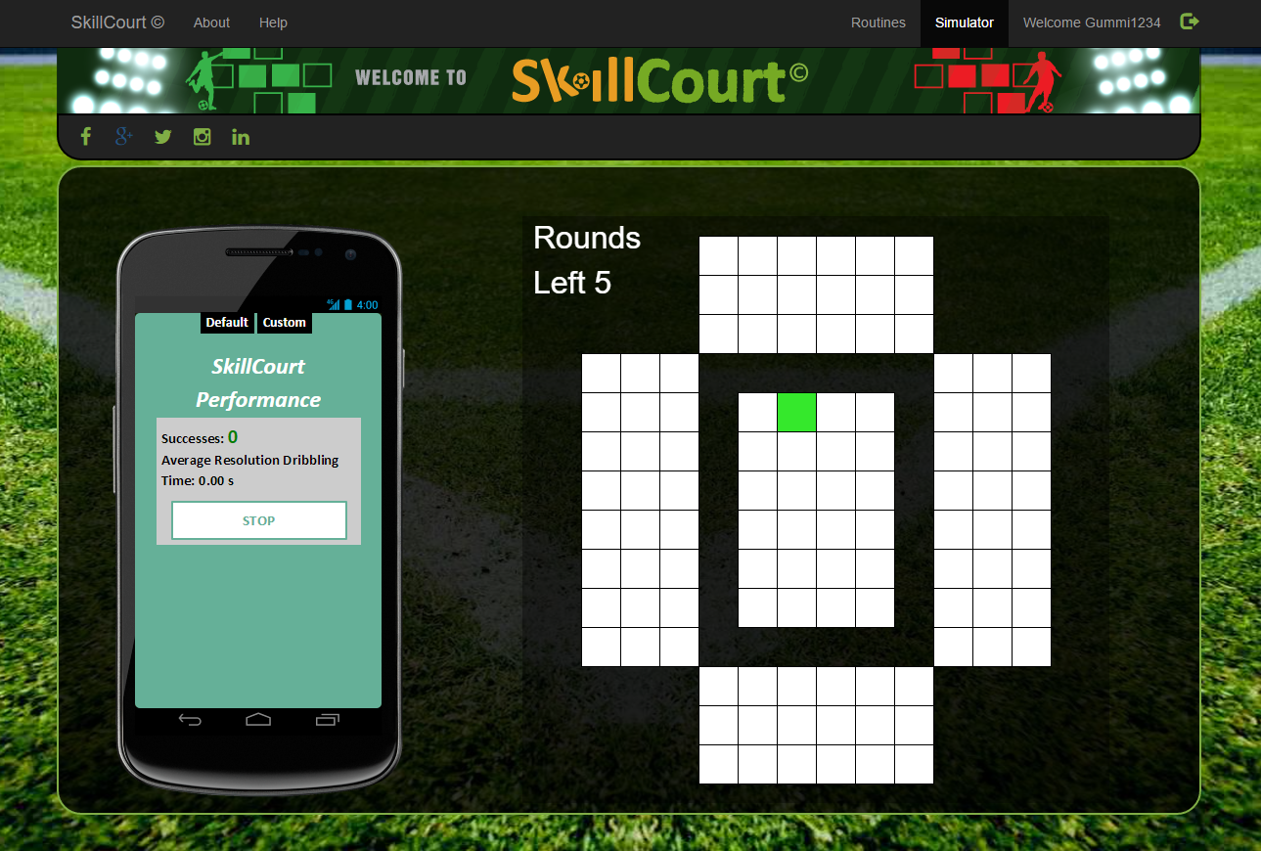

### Simulator

As a player, the simulator is always available. Even if no routines are assigned, the player can play a routine from the pre-defined system routines.

1. Click on the Simulator link
2. Choose options to play.
3. Interactive Tutorial is available by clicking Help tab
4. Click on Play to start simulation.

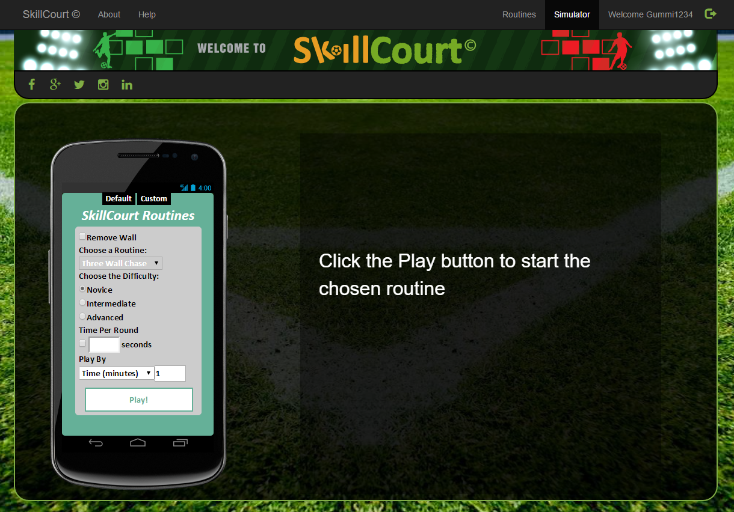

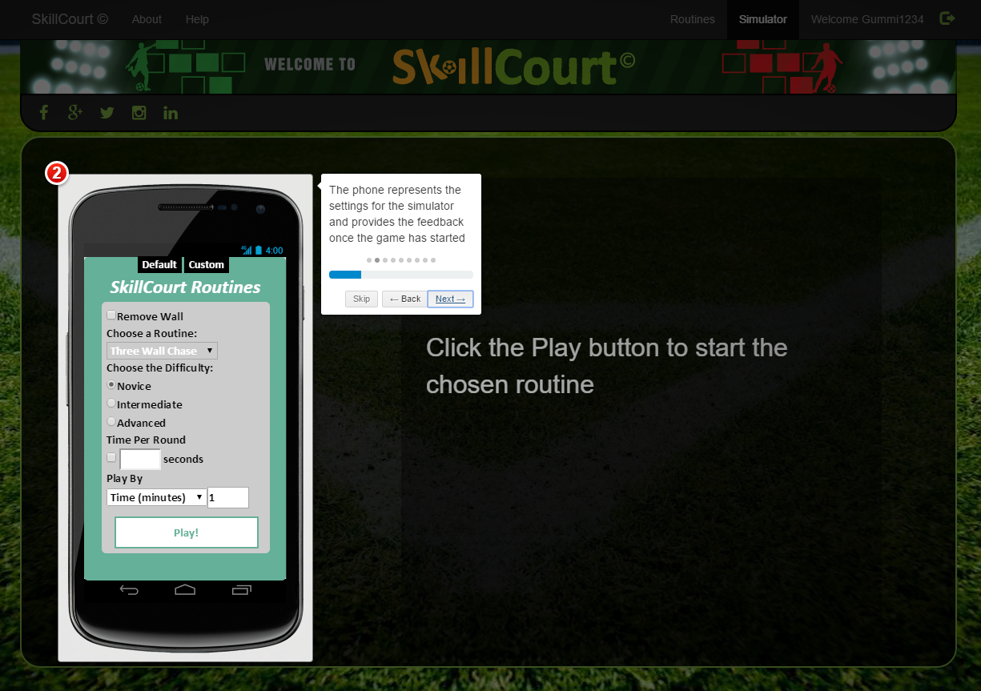

## 3. Manage Account Information

A user has the ability of resetting their password, by clicking on the info button right next to the login button. It is to note, that the system will not allow you to send a request to reset your password if the imputed email address does not exist in the database.

